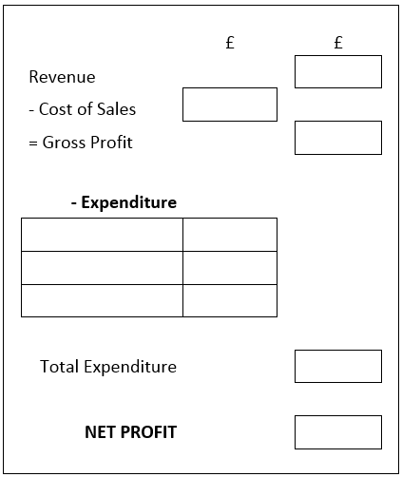
R

Revenue- £10,000 Revenue- £16,500
Cost of Sales- £3,000 Cost of Sales- £3,700
Expenditure- WAGES- £1200, STOCK- £800, EQUIPMENT- £450 Expenditure- WAGES- £1570, STOCK- £1200, EQUIPMENT- £300

